4D3N YANGON – GOLDEN ROCK – BAGO - YANGON
DAY 1: YANGON ARRIVAL – CITY SIGHTSEEING ( L, D )
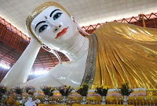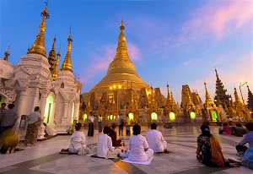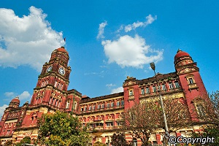
Chauk Htat Gyi pagoda Shwedagon Pagoda Yangon high court building

Arrive at Yangon International Airport. Transfer to your hotel and then visit to the Chaukhtatgyi Reclining Buddha. Enjoy the lunch at restaurants. After lunch, continue to the the world famous Shwedagon Pagoda - this Pagoda dates back about 2600 years enshrined 8 sacred hairs of the Buddha, claimed to be the world richest golden dome rises 99 meters and plastered onto the sides of this pagoda with 60 tons of pure gold. Dinner & Overnight in Yangon.

Meals: 1 Lunch + 1 Dinner
Accommodation: Overnight in Yangon
The distance: Yangon International Airport - Yangon city: 20km - 40 minutes for transfer.

DAY 2: YANGON – BAGO – KYAIKHTIYO ( B/L/D)
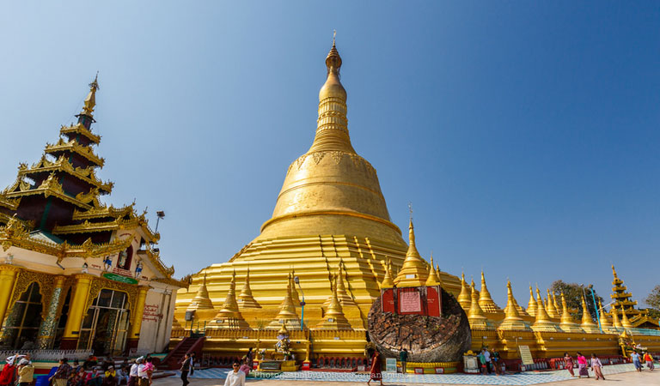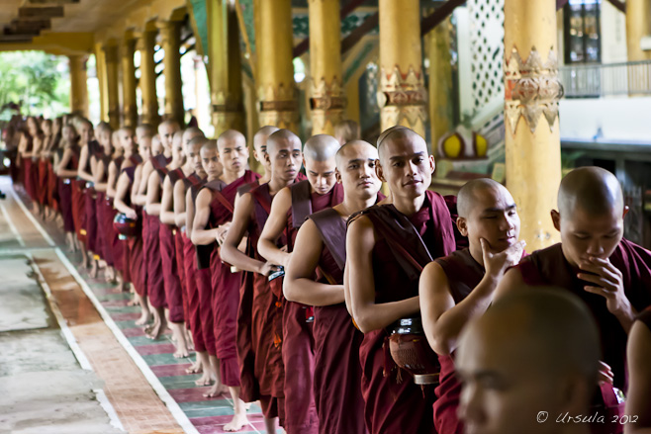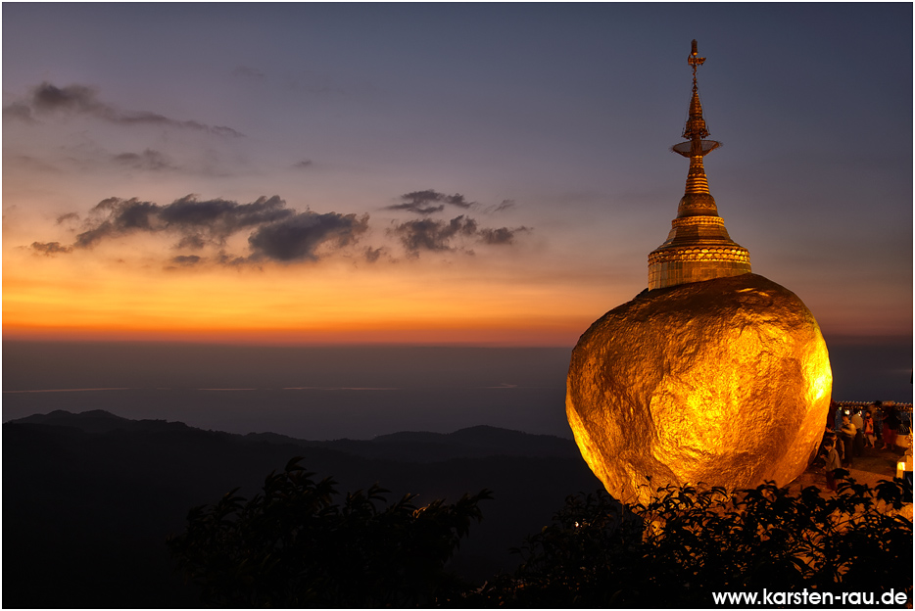
Shwe Maw Daw Pagoda Kyakhatwine Monastery Kyaikhtiyo Pagoda

Breakfast at hotel. Drive to Kyaikhto. On the way you can visit an ancient capital Bago. The places to see in Bago are Shwe Maw Daw Pagoda which is like Shwedagon in Yangon at glance and the highest Pagoda in Myanmar, Kyakhatwine Monastery, one may observe over 600 student monks having lunch under the way of Buddha’s guidance. After lunch, drive to Kyaikhtiyo (The Miracle of Golden Rock) a huge boulder which maintains its precarious balance due to a precisely placed Buddha hair in the stupa. Arrive Kin Pun base camp, proceed to top mountain by the open truck. Enjoy sunset at Golden Rock Pagoda. Dinner in hotel. Overnight at Hotel in Kyaikhtiyo.

Meals: 1 Breakfast + 1 Lunch + 1 Dinner
Accommodation: Overnight in Kyaikhtiyo .
The distance: Yangon Capital – Kyaikhtiyo Pagoda : 160km – 4 hours for transfer & break time on the way.

DAY 3 : KYAIKHTIYO - YANGON (B/L/D)
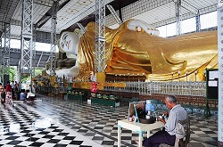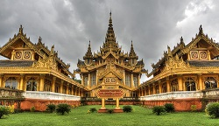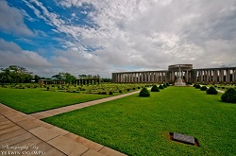
Shwethalyaung pagoda Kanbawzathardi Palace Htauk Kyant War Cemetery

After breakfast, descend from Pagoda and drive to Bago. On your way back to Yangon you can visit some more places in Bago such as: Shwethalyaung Pagoda 55 meters long and 16 meters high reclining Buddha, Kanbawzathardi Palace the famous palace of King Bayinnaung (1551-1581 A.D.) is being extensively excavated and some buildings are being rebuilt. After lunch, continue to Kyeik Pun, Four-sided Pagoda built by King DhammaZedi in 1476 A.D, Htauk Kyant War Cemetery maintained by the common wealth War Graves Commission. Dinner at hotel & overnight in Yangon.

Meals: 1 Breakfast + 1 Lunch + 1 Dinner
Accommodation: Overnight in Yangon.
The distance: Kyaikhtiyo - Yangon Capital: 160km – 4 hours for transfer & break time

DAY 4 : YAGON SEIGHTSEEING & DEPARTURE (B/-/-)
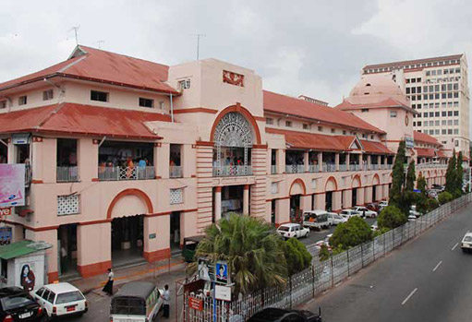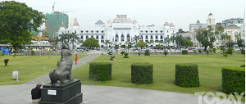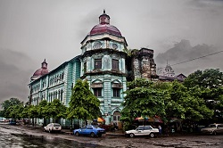
Bogyoke Market ( or ) Scott market Maharbandoola Park Myanmar Heritage Building

After breakfast, shopping to Bogyoke or Scott’s Market, a famous shopping center to enjoy display of Myanmar handicraft and Gems Shops & enjoy walking tour from Sule Pagoda & visit to the Maharbandoola Park, 48 meters golden dome explore a great city and this tour takes in the best of Myanmar Heritage Building in Yangon. And then transfer to Yangon International Airport from Myanmar.

Meals: 1 Breakfast
The distance: Yangon Capital – Yangon International Airport: 20km - 40 minutes for transfer.

SEQUENCE OF ITINERARY SUBJECT TO LOCAL ARRANGEMENT
PRICE INCLUDE:
- Accommodation – as hotel in the list or similar – based on Twin/Double/Triple sharing
- Tour guide: English speaking guide during the tour.
- Daily ABF and meals as mentioned in the program
- Shows and sightseeing in schedule.
- Transportation by private air-conditioner.
- 01 bottle (500 ml) of drinking water for each pax per day.
- Meals (Burmese Food & Chinese Food) as the tour code ( B: Breakfast, L: lunch, D: Dinner)
- Truck in Kyaikhtiyo mountain

PRICE EXCLUDE:
- International/ Domestic flight ticket & airport tax
- Personal expenses: Tel, Fax, Mini Bar, Laundry,etc.
- Personal travel insurance
- Compulsory Tip for local guide and driver (USD/PAX/DAY)

Group Size | Tips in USD
2 – 4pax | 6
5-7pax | 5
8 - up | 3

- Surcharge with other languages guide.
- Surcharge at hotel case by case
  - Burmese New Year (TBA)
  - Gala Dinner on X’Mas (24 Dec ) & New Year (31 Dec)

Hotel listed or Similar |  | All rates are next in USD/pax  valid for LOW SEASON from 01 May 19 to 30 Sep 2020
 |  | Tour by private car / bus with private guide
YANGON | KYAIKHTIYO | 2 | 3-4 | 5-6 | 7-9 | 10-12 | 13-15 | 15+1 | 20+1 | 25 +1 | 30+1 | SGL SUP
Hotel Grand United Ahlone 3*  Hotel Grand United China Town 3*  Hotel Grand United donwntown -21st str 3* | Hotel Kyaikhtio 3* | 380 | 325 | 265 | 245 | 235 | 220 | 215 | 205 | 195 | 190 | 75
Taw Win Garden Hotel 4* | Mountain Top Hotel 3* | 430 | 375 | 315 | 295 | 285 | 270 | 265 | 255 | 250 | 240 | 125
Park Royal Hotel 5*  Chatrium hotel 5* | Mountain Top Hotel 3* | 455 | 400 | 340 | 320 | 310 | 295 | 290 | 280 | 270 | 265 | 145

Hotel listed or Similar |  | All rates are next in USD/pax  valid for HIGH SEASON from 01 Oct 18 to 10 Apr 2019
 |  | Tour by private car / bus with private guide
YANGON | KYAIKHTIYO | 2 | 3-4 | 5-6 | 7-9 | 10-12 | 13-15 | 15+1 | 20+1 | 25 +1 | 30+1 | SGL SUP
Hotel Grand United Ahlone 3*  Hotel Grand United China Town 3*  Hotel Grand United donwntown -21st str 3* | Hotel Kyaikhtio 3* | 425 | 370 | 310 | 290 | 280 | 265 | 260 | 250 | 240 | 235 | 120
Taw Win Garden Hotel 4* | Mountain Top Hotel 3* | 455 | 400 | 340 | 320 | 310 | 295 | 290 | 280 | 270 | 265 | 145
Park Royal Hotel 5*  Chatrium hotel 5* | Mountain Top Hotel 3* | 520 | 465 | 405 | 385 | 375 | 360 | 355 | 345 | 340 | 330 | 205

NOTE

The timing of sightseeing points shall be fixing by local operator due to traffic and weather conditions, however all points must cover unless amendment or cancellation make by clients themselves (Non-refundable for any cancellation that made by clients)

Tour and price are subject to change without notice or incase of deduct number of pax in quoted group.

Small deviations in the tour program are sometimes necessary, depending on weather, road conditions, flight schedules and room availability.

Supplement charge for room rate in peak dates depends on the hotel category used. Compulsory gala dinner on X’mas, New Year’s Eve & Water Festival days to be advised upon booking. Prices for group of 15 persons up in 5 stars hotels sometime requires to re-quote bases on the hotel policy.

Group tour 20 pax, you will get 01 FOC for tour leader based on twin sharing basis include breakfast (domestic air ticket is not applicable)

BUS

Group Size | Kind of Transportation
1-2 pax | 4 seater
3 pax | 7 seater
4-9pax | 16 seater
10-18 pax | 30 seater
19-21 pax | 35 seater
22 – 42 pax | 45 seater

CHILD POLICY

- Infant below 2 years old sharing same room with parents is free of charge.
- Child below 12 yrs old sharing same room with 1 ADL is charged for 90%.
- Child below 12 yrs old with extra bed and sharing same room with parents is charged for 65%.
- Child below 12 yrs old No extra bed & sharing same room with parents is charged for 55%.

TERM & CONDITIONS

1. CANCELLATION
In case of cancellation, fees will be charged accordingly to the day that official notice in writing is received at Hanoi Office: No 11, lane 8, Doi nhan, Ba Dinh district, Hanoi-Vietnam.

- Before 30 days: No charge
- Less than 30 days: 50% of total tour price
- Less than 14 days: 75% of total tour price
- Less than 7 days before arrival date or no-show: 100% of total tour price

Any cancellation due to irresistible reasons such as wars, strikes, earthquakes, etc. will be considered subject to each case.

